Discussion Groups

Armageddon

Kingdom Conference 2020

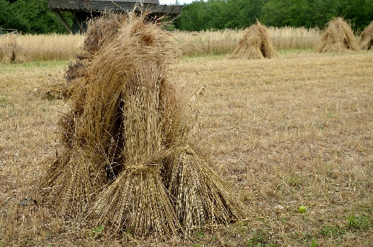
Discussion Group 2: Armageddon

‘[God] hath appointed a day, in the which He will judge the world in righteousness’
The whole world is going to be judged by God, why is this judgment necessary? What is the purpose of it?

A major part of the judgment on the nations will be the battle of Armageddon. Prophecies such as Ezekiel 38, Daniel 11, Joel 3 speak of this battle.
What are the parallels in these passages?
Can you think of any other Armageddon prophecies?

Give a short summary of the main aspects of this battle:
Who’s involved? What’s the outcome?

What is our part in the battle of Armageddon?

How can we see the scene being set for the battle around us in our time?

How should this affect our lives now?
How can we help those around us to be ready for this time?

Bonus questions
Where will the battle take place?

It appears that Armageddon is made up of 3 words from the Hebrew tongue:
Aremah – heap of sheaves (example usage in Jeremiah 50.26)
Ge – valley (example usage in Jeremiah 7.32)
Don – judgment (example usage in 1 Samuel 2.10)
It gives a word picture to us of a heap of sheaves, gathered into a valley to be threshed/judged. Can you think of verses in the prophets that also show this same picture?

Any other questions about Armageddon that you would like to discuss?

